**Card Design - Globs**

* Name on the top
* HP just underneath name
  + Grows with each level
  + Increase by 17 * level for now)
  + Commons base HP: 260
  + Uncommon: 320
  + Rare: 400
  + Epic: 475
  + Legendary: 530
* Level in corner
  + Common globs start at level 1
  + Uncommon globs start at level 2
  + Rare globs start at level 4
  + Epic globs start at level 10
  + Legendary globs start at level 20
* Image below these three
* Attack
  + Fighting against a weakness doubles damage received
  + “Adjacent” colors receive half the damage (polish?)
  + Does not consume mana (?)
* Special Attack
  + Consumes mana
  + Unique to each glob
  + Can be either a supporting ability or an attack
  + Legendary can have both (?)
* Defense
  + Halved when fighting against a weakness
  + Doubled when fighting against “adjacent” colors
* Mana
  + Used to make special attacks
  + Damage received by the enemy is added as mana (maybe 2/3 to a half?)
* Rarity
  + Placed in the bottom corner of card
  + Determines how high of a chance you can get the card
  + Five rarities:
    - Common – 100%
    - Uncommon – 80%
    - Rare – 60%
    - Epic – 40%
    - Legendary – 20%
* Color
  + Determines weaknesses (maybe strength too)
* Additional stats, such as weakness and description, can be found in a gallery-type setting
  + i.e. outside of the game, collections, decks, store
  + The game would only display the essentials listed above
* EXP
  + Every glob starts with no exp
  + Level cap grows like HP with same stats
  + Experience gained is sum of levels of globs beaten * 16

**Card Design – Items**

* Items increase boost a certain attribute of a card
  + Boost/Restore HP
  + Boost Attack
  + Boost Defense
  + Boost/Restore Mana
  + Increase Level (outside games, this one’s a maybe)
  + Block/Stop opponents attack
  + Change Glob alliances (in-game only)
  + Pull a card from discard pile
* Name on top
* Image just below
* Description below that
* Color of card is random (? – polish)

**Game Mechanics**

* First match with an opponent
  + Can be anyone within the vicinity (?)
  + If no requests are accepted within a certain time frame, cancel the game
  + Return player to matching screen to try again
* Once matched, go to deck screen
  + Pick a deck the player wants to use against the other opponent
  + Must select within a certain time frame
  + Outside that time frame, let other player know initial player dropped the match
  + This is to ascertain the player is still willing to play a match
* Deck is chosen – go to main battle screen
  + Battle screen kinda looks like this (thanks Dez for visual):

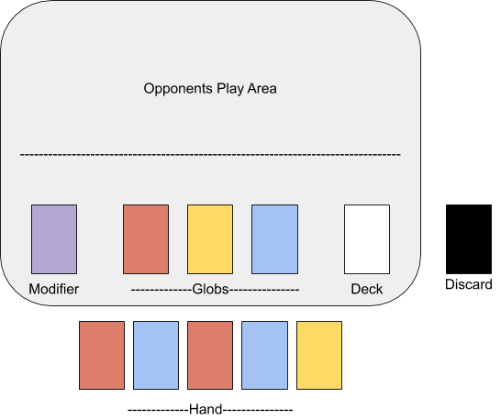

* Match begins
  + Each player draws five cards then places (up to) three globs onto the field
  + Whoever has the highest average level of these globs goes first
  + Each turn consists of 3 actions:
    - Normal action
      * Play a card
        + Basically, placing it on the field
        + If it’s a modifier, the effects are activated the same turn
      * Discard
        + A player can only have a max of five cards in hand
        + Players have an opportunity to discard a card if they think they don’t need it
        + Or if they feel like they need to switch a card out
      * Skip turn
        + Completely ends the turn
        + Player does not go through Battle or Draw actions
    - Battle Action
      * Action/action/ability
        + Have a glob attack

Damage happens when attacking glob’s attack is greater than defending glob’s defense

The damage taken is equal to the difference of the two

Mana gained by attacking glob is the same value (?)

* + - * + Use a glob’s special attack/ability

Does not return any mana (? – most likely)

* + - * Switch globs
        + When a glob’s health is beginning to get low
        + A player can switch it out for “recovery” (?)

25-50 HP recovery per turn (or less)

* + - * + Discard it completely (initial idea)
    - Draw Action
      * Draw a card
      * This is automatically grayed out when player has five cards in hand
      * Skip Draw Action
  + Each player continues taking turns until one of them:
    - Runs out of cards
    - Has all their live globs (globs on the field) taken out (HP = 0)
  + Match ends
* Player is taken to Win/Lose page
* Player collects prizes (if any)
* Option to return to main page or match page
  + Could also return straight to match page

**Currency**

* Called Dots
* 1• is equivalent to 10₵ (can be changed later)
* Used for buying cards in shop
* Can be earned by:
  + Selling unneeded cards (?)
    - Common – 10•
    - Uncommon – 20•
    - Rare – 40•
    - Epic – 80•
    - Legendary – 160•
  + Winning matches
    - This money is *not* from the other player!!!
    - Winners get prize money
    - Losers also get money as a thank you for playing (?)
      * The amount equals to a quarter of the prize money (or more)
  + Daily Bonuses/Missions
* Buying in bulk reduces price